Michigan EAB project – questions, methods, results
Aaron Tayal
Jan 24, 2025

Challenge paragraph (last paragraph of introduction):

Given the uncertain future of ash regeneration in the variety of forest types where ash is present, we initiated a project to assess the occurrence and health of ash in long-term research plots. Because soil hydrology (the degree of water saturation in the soil) is important for plant community composition, including the relative commonness of the three major species of ash, we used soil hydrology as our predictor variable. We asked whether the abundance of ash seedlings, saplings, and/or trees would differ based on the soil hydrological class of a forest stand. We did not make a specific hypothesis a priori regarding hydrological class. We did hypothesize that newly germinated ash seedlings would be absent from all stands, which would be consistent with the absence of seed-producing ash trees and the depletion of the ash seedbank. In addition to ash occurrence, we also asked if ash saplings and/or trees would show evidence of EAB attack. Consistent with previous studies, we expected that ash trees with larger diameters would have more signs and symptoms of EAB.

Methods:

Study area:

Our study was conducted in predominately deciduous forest in Oakland and Washtenaw Counties, in southeast Michigan. Forest stands were in three Huron-Clinton Metroparks (Indian Springs, Kensington, and Hudson Mills) and four State Recreation Areas (Pontiac, Highland, Proud Lake, and Island Lake). Many of the stands are located near the Huron River, and all are in the Huron River Watershed, which flows into Lake Erie (https://www.hrwc.org/our-watershed/maps/). The geology of the area consists of sandy outwash plains interspersed with coarse-textured ground and end moraines (Kost and O’Connor 2003).

We visited 37 stands which have been previously established to study the invasion of EAB and its ecological consequences (Smith 2006; W. Klooster et al. 2018). Of these, 30 were established in 2004-2005, while the remaining 7 were established in 2007-2008. Stands were selected to encompass a range of distances (24-48 km, 15-30 miles) from the epicenter of EAB invasion in Canton, MI. Stands varied in “soil moisture, dominant overstory species, topography, ash density, ash frequency, community composition, total basal area, and tree density” (Smith 2006). Because soil moisture plays a large role in structuring tree communities, stands were grouped into three hydrological classes based on soil moisture and ash species. Stands in floodplains or depressional areas, with water-saturated soils and standing water for part of the year, and which had black ash (Fraxinus nigra) and/or green ash (Fraxinus pennsylvanica), were classified as hydric. Stands with moderately well-drained soils, and which had green ash and/or white ash (Fraxinus americana), were classified as mesic. Stands in upland forest with white ash were classified as xeric. Ash (Fraxinus) composed, on average, 20% of the overstory basal area of xeric transects, 24% of the basal area of mesic transects, and 30% of the basal area of hydric transects in 2004. Other common tree genera include maples (Acer), oaks (Quercus), cherry (Prunus), hickory (Carya), tuliptree (Liriodendron), aspen and cottonwood (Populus), elm (Ulmus), basswood (Tilia), hophornbeam (Ostrya), and musclewood (Carpinus). Tree species community composition was driven partly by hydrological class, with hydric stands being distinct in composition from mesic and xeric stands (page 71) (Smith 2006).

In each forest stand, hereafter referred to as a transect, a total of three replicate plots were established, for a total of 111 plots. Each plot within a transect was selected to have similar “topography, soil moisture, tree size class distribution, and herbaceous layer” (page 64) (Smith 2006). The 1st plot of a transect was selected based on the criterion that it contained at least two mature ash trees (in 2004-2005). The 2nd and 3rd plots of a transect were selected by taking a random compass direction from the previous plot. A buffer region of 5-25 meters was ensured between the edges of each plot, depending on what the size of the stand allowed (Smith 2006).

Plot design:

The study plots have a multiscale sampling design to facilitate surveys of different sizes of vegetation. An 18 m radius (0.102 ha) circular main plot contains an 8 m radius (201 m²) circular subplot, and four, 4 m² area circular microplots, one in each cardinal direction from the center. In the main plot, subplot, and microplots, we sampled ash trees, small trees and saplings, and seedlings, respectively (see below).

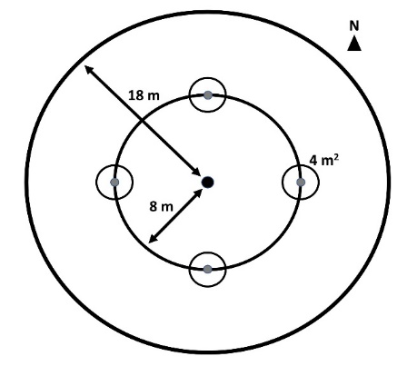

Ash abundance and health:
To assess the abundance and health of ash in the Huron River Watershed, we surveyed the 37 transects. We surveyed ash big trees (≥10 cm diameter at breast height, DBH) within 18 m radius main plots, ash small trees (between 2.5-10 cm DBH) and ash saplings (≥137 cm in height but <2.5 cm DBH) within 8 m radius nested subplots, and ash seedlings (<137 cm in height) within microplots located at cardinal directions from the plot center. We measured DBH at a height of 137 cm using a DBH tape measure (Ward et al. 2021).

To survey ash seedlings, we counted number of stems in two height categories, <25 cm and >25 cm, and we also estimated the percentage cover of ash seedlings using the scale <1%, 1%, 2-5%, 6-10%, 11-20%, 21-30%, 31-40%, …, 91-100% (Klooster et al. 2014). Only percentage cover of ash seedlings was included: ash taller than 137 cm was not considered for percentage cover estimates.

For ash saplings, we counted the number of living stems in the subplot and noted the number of stems exhibiting signs and symptoms of EAB attack. We assessed the presence or absence of multiple features which can indicate that EAB larvae have attacked the vascular system. First, we looked for the presence of D-shaped emergence holes where adult EAB emerge from the bark. Second, we looked for symptoms that are often found on infested trees, including woodpecker predation marks, bark splitting, epicormic sprouts, and basal sprouts (Knight et al. 2014). Basal sprouts were defined as sprouts starting at ground level, while epicormic sprouts were those sprouts starting from the trunk.

To inventory the ash trees, including small trees in subplots and big trees in main plots, we recorded information individually for each tree. First, we recorded the DBH of a tree and its species, if possible. Then, we rated the canopy condition using a 1 to 5 scale, where 1 represents healthy canopy foliage, and 5 represents complete defoliation of the canopy (Smith 2006). We rated a tree as having canopy condition 5 even if there were small living sprouts on the trunk. After rating canopy condition, we assessed the presence or absence of the EAB signs and symptoms mentioned previously. If two stems of a small tree were clearly connected at the base (for instance, if one stem was the basal sprout of another stem), then we only recorded information for the stem which had the larger DBH.

The species of ash was assessed using multiple field marks. Due to the near absence of ash seeds to use for identification, we found that we could only consistently distinguish black ash (Fraxinus nigra) from the other Fraxinus species. Black ash was distinguished by its higher number of leaflets per leaf, lanceolate (?) leaf shape, presence of tomentum where leaflets meet on the rachis, and presence of corky bark. Although white ash can be distinguished from green ash by its longer petiolules and horseshoe-shaped leaf scars, we found these characters too variable to permit reliable identification. We grouped our species designations into three categories: 1) black ash 2) all other species of ash but not black ash (including white ash, green ash, and potentially pumpkin ash), and 3) unknown ash species (often because the tree was dead). We reported the stem densities and basal areas of the species categories for each transect where ash was present.

Statistics – ash occurrence:

From the counts of ash seedlings, saplings, small trees, and trees, we calculated plot-level densities of each size class. We did this by dividing the number of stems by the area over which they were counted. Then we pooled the three plots in each transect together to obtain transect-level mean densities. For ash trees, density of standing dead ash trees (canopy condition = 5) were calculated separately from density of living ash trees (canopy condition < 5). In addition to stem density of ash small and big trees, the basal area of living small and big ash was calculated. Basal area was calculated for each tree individually using the formula Σ(π*(d/2)²), where d is the DBH of a tree. Then, the areas of all small trees were summed and then divided by the subplot area, and the areas of all big trees were summed and then divided by the plot area. Basal area was reported in units of m²/hectare.

We used the existing categorization of transects (n=30) by hydrological class (xeric (18 transects), mesic (7 transects), and hydric (5 transects)) to test whether the abundance of ash differs based on soil moisture level. Our response variables were number of short ash seedlings (count), number of tall ash seedlings (count), mean percentage cover of ash seedlings (continuous), number of ash saplings (count), and number of living small ash trees (count). We created separate models for each response variable. Hydrological class (xeric, mesic, or hydric) was treated as the fixed effect and Park where transect is located as random intercepts to account for unique site conditions at each of the seven parks. For each response variable which is count data, we first tried a Poisson generalized linear mixed-effects model (GLMM) with a log link function, implemented using the package ‘lme4’ in R. We used the package ‘DHARMa’ to determine if the observed data was adequately modelled by the GLMM. Specifically, we tested for over- or underdispersion by a data simulation. First, we simulated data based on the fitted parameters of the GLMM, while conditioning on the fitted intercepts for each Park. Then we compared the standard deviation of the observed DHARMa residuals to the standard deviation of the simulated DHARMa residuals, using a nonparametric test. Whenever the Poisson GLMM was determined to be overdispersed (that is, the variance of the observed residuals was higher than that of the simulated residuals), we created a new model using the negative binomial error structure. This was implemented using the ‘lme4’ and ‘MASS’ packages in R. We similarly observed the residuals of the negative binomial GLMM to verify model fit. We compared the Akaike Information Criterion (AIC) between the Poisson and negative binomial models to verify an improvement in model fit. The models for number of saplings and number of small trees were a singular fit or did not converge, so we dropped the random effect of Park for these response variables. Thus, the number of saplings and number of small trees were modelled using a negative binomial generalized linear model with hydrological class as the predictor.

For the mean percentage cover of ash seedlings, each data point was the average cover of ash seedlings across the 12 microplots in a transect, so we treated this variable as continuous. To determine if differences existed in ash seedling percentage cover among transects of different hydrological class, we tried a linear mixed-effects model with normally distributed residuals. However, the model violated the assumption of homoscedasticity of residuals. In response, we transformed the response variable using the formula y’ = ln(y + 1), where y is the mean percentage cover. We then ran a new linear mixed-effects model using the transformed percentage cover. This new model satisfied homoscedasticity of residuals and approximate normality of the residuals, and the random intercepts for each Park were clustered together more than in the original model, showing an approximate normal distribution. The graph is presented using the un-transformed mean percentage cover in the y-axis.

We performed Analysis of Deviance (Type III Wald Chi Square tests), using the R package “car” to test for differences in the response variables among hydrological classes. We followed up with pairwise comparisons using a p-value adjustment based on the Tukey method for comparing a family of 3 estimates, implemented using the R package ‘emmeans’. We presented figures with the response variables as densities (counts of ash divided by area over which they were counted) even though we conducted analyses using the raw count (natural number) data.

To investigate the number of living big ash trees (≥10 cm) in transects, we presented the results graphically. This is because only two transects had nonzero numbers of ash trees ≥10 cm in their plots. Similarly, the total basal area of small and big ash trees was presented graphically, due to the high number of zeros and the wide variability in basal area between transects.

Statistics – ash health:

We hypothesized that as ash regeneration in the understory grows bigger, it will become susceptible to EAB attack, and thus show more signs and symptoms of EAB. To test the prediction that ash tree diameter is positively correlated with signs and symptoms of EAB attack, we used binomial generalized linear mixed-effects models with logit link functions. Diameter at breast height (DBH) was the fixed effect. We included plot as a random intercept to account for non-independence of trees in a plot. We excluded any tree belonging to a plot where less than 10 trees were found, which gave us a sample size of 274 trees. We further removed two trees which had missing values for presence of basal sprouts, which brought our sample size to 272 trees. These were in 9 plots, within 6 transects at 3 different parks (Indian Springs, Island Lake, and Proud Lake). Five of the 6 transects in the analysis were classified as hydric, and 1 (transect “CC” at Island Lake) was classified as mesic. We considered including ash species in our model, because the susceptibility to EAB attack varies by species. However, usually only one species of ash tree would comprise most of the ash trees in a given plot, making it difficult to decouple plot and ash species as predictors. To assess the accuracy of the models, we created binned categories of tree diameter and calculated the proportion of trees in each bin that showed the sign or symptom. We observed whether our model line passed through the proportions for each bin.

For the analysis of the canopy condition of ash trees (the stage of defoliation), this variable was initially recorded on a 1-5 scale, with 1 being a healthy canopy and 5 representing complete defoliation. To convert this measure into binary response variables, we created a response called “ash tree death” which was defined as 1 if canopy condition = 5, and 0 if canopy condition was between 1-4. We also created a response called “ash tree decline” which was defined as 1 if canopy condition was ≥ 2, and 0 if canopy condition = 1. We then analyzed these response variables similarly to the other signs and symptoms of EAB attack. Finally, we presented a histogram of the relationship between ash tree DBH, ash species, and canopy decline.

Results:

Transects that varied in their hydrological class, from hydric forest in flooded areas, to xeric forest in upland sites, were investigated for the occurrence and health of ash. All metrics of ash abundance are reported at the transect level, which consisted of three plots.

Ash seedlings (<137 cm in height):

A total of 2826 ash seedlings were counted in the microplots of the 30 transects. Ash seedlings were found in stem densities ranging from 0 to 5.4 stems/m², with an average of 2.0 stems/m². Short (<25 cm) and tall (25-137 cm) seedlings averaged 1.1 stems/m² and 0.9 stems/ m², respectively. The transect with highest number of short ash seedlings was “X”, a mesic transect at Highland Recreation Area. The transect with highest number of tall ash seedlings was “V”, a mesic transect at Indian Springs Metropark. Mean percentage cover of ash seedlings ranged from 0% to 38%, with an average of 12% across all transects. The transect with highest mean percentage cover of ash seedlings was “ZC”, a xeric transect located at Pontiac Lake Recreation Area.

Number of short ash seedlings varied by hydrological class (χ²=10.9, 2 degrees of freedom, p=0.004). Hydric transects had lower numbers of short seedlings than mesic (Z=-3.3, p=0.003) and xeric (Z=-2.6, p=0.027) transects, while differences between mesic and xeric transects were not statistically significant (Fig. 1A). Similarly, number of tall ash seedlings differed by hydrological class (χ²=12.7, p=0.002), with hydric transects having lower numbers than either mesic (Z=-3.5, p=0.001) or xeric (Z=-2.7, p=0.019) transects (Fig. 1B). In mesic and xeric transects, the percentage cover of ash seedlings averaged 17% and 12%, respectively, but hydric transects had only 3% ash seedling cover on average. Percentage cover of ash seedlings varied by hydrological class (χ²=12.4, p=0.002), with hydric transects significantly lower than mesic transects (t=-3.2, p=0.010) and xeric transects (t=-3.0, p=0.018) (Fig. 1C).

Ash saplings (≥137 cm in height and <2.5 cm DBH):

A total of 897 saplings were counted in the 30 transects. The density of ash saplings, across the 30 transects, ranged from 0 to 0.539 stems/m² (0-5390 stems/hectare), with an average of 0.050 stems/m² (500 stems/hectare). The transect with maximum number of saplings was “ZG”, a xeric transect located at Kensington Metropark which had a somewhat open canopy of black walnut (Juglans nigra). Any differences in number of saplings based on transect hydrological class were not significant (χ²=0.4, p=0.82) (Fig. 1D).

Out of a sample size of 994 saplings (this includes data from 97 plots), signs or symptoms of possible EAB attack were found on a total of 55 saplings. By far the most common sign or symptom on saplings was bark splitting, which was found in 31 subplot quadrants out of 150 subplot quadrants with ash saplings. Other signs and symptoms of EAB were relatively rare or absent on ash saplings, including EAB exit holes (not found on saplings), woodpecker predation marks (found in 1 subplot quadrant), epicormic sprouts (found in 6 subplot quadrants), and basal sprouts (found in 3 subplot quadrants).

Ash small trees (2.5-10 cm DBH) and big trees (≥ 10 cm DBH):

A total of 187 small ash trees were found in the 30 transects. Of these, 149 were living (canopy condition ≠ 5), while 38 were dead and at least partly standing. The density of living small ash trees ranged from 0 to 1011 stems/hectare, with a mean of 82.3 stems/hectare and a median of 0 stems/hectare. The transect with the highest number of small trees was “H”, a hydric transect at Proud Lake Recreation Area. The number of living small ash trees varied by transect hydrological class (χ²=8.38, p=0.015). Hydric transects had more small ash trees than xeric transects (Z=2.5, p=0.033), but the other pairwise comparisons were not significant (Fig. 1E).

For the ash species summary, we included trees found within plots of transects that have not been completed yet as of 2024. This is 97 plots rather than the 90 plots used for the previous analysis. In the 97 plots, we found 313 small trees. Of these, 177 (56%) were black ash, 115 (37%) were green, white, or pumpkin ash, and 21 (7%) were not identified. In hydric forests, out of 271 trees, there were 155 black ash small trees, 102 green, white, or pumpkin ash, and 14 unidentified ash small trees. In mesic forests, out of 20 small ash trees, 16 were black ash and 4 were unidentified. In xeric forests, out of 22 small ash trees, 6 were black ash, 13 were green, white, or pumpkin, and 3 were unidentified.

We observed that many hydric transects were composed mostly of black ash small trees, with only a few green or pumpkin ash. However, one hydric transect (transect “U” at Indian Springs) had higher numbers of green or pumpkin ash. Furthermore, one xeric transect (transect “E” at Proud Lake) had black ash (Fig. S2).

Small and big ash trees were pooled for this analysis. Out of a total of 320 trees, 220 (69%) had canopy condition=1 (meaning they were healthy), 31 (10%) had canopy condition=2, 12 (4%) had canopy condition=3, 7 (2%) had canopy condition=4, and 50 (16%) had canopy condition=5 (meaning they had a dead canopy).

The diagnostic sign of EAB presence, the exit holes where adult EAB emerged from a tree, were relatively rarely found, with only 8 ash trees (2%) out of 321 having exit holes that were found (Fig. S1).

Of the symptoms of EAB, bark splitting was the most common and was found on 179 (56%) out of 321 ash trees. Epicormic sprouts were second-most common, found on 116 (36%) of ash trees. Basal sprouts and woodpecker predation marks were found on 46 (14%) and 40 (12%) ash trees, respectively.

Ash big trees (≥ 10 cm DBH):

Only 9 trees were found in the 30 transects, of which 7 were living (Fig. 1F). The two transects where living big ash trees were found were “H”, the same transect that had the highest numbers of small ash trees, and “S”, a hydric transect at Indian Springs. Living big trees within the plots ranged in diameter from 10.3 cm DBH to only 12.4 cm DBH.
Out of 9 big ash trees, 4 were black ash, 3 were green, white, or pumpkin ash, and 2 were unidentified ash species.

Basal area of ash:

The basal area of living small and big ash trees combined (all ash ≥ 2.5 cm DBH and canopy condition ≠ 5) ranged between 0 and 2.61 m2/hectare, with an average of 0.18 m2/hectare. The transect with highest basal area of living ash trees was transect “H” at Proud Lake.

B
A
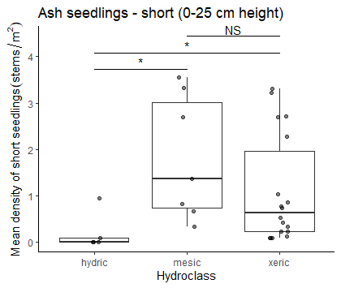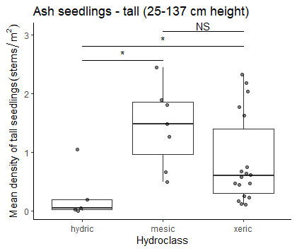
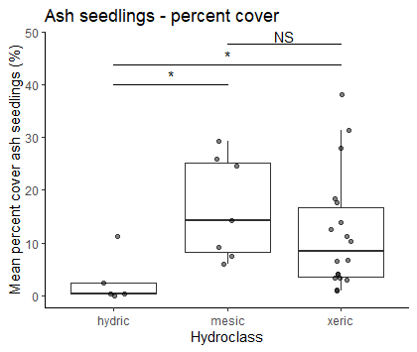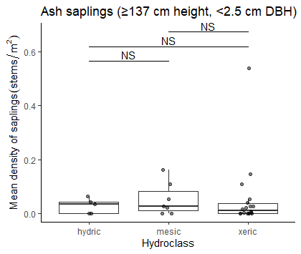
F
E
D
C
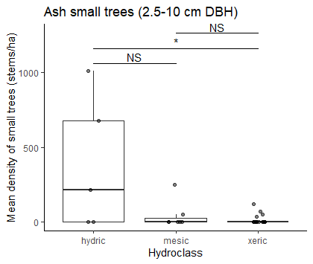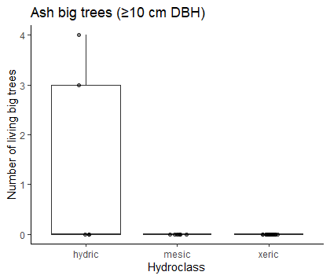
Figure 1. Ash occurrence by size category in 30 transects varying in soil hydrological class. A) Mean density of short ash seedlings, B) mean density of tall ash seedlings, C) percentage cover of ash seedlings, D) mean density of ash saplings, E) mean density of small ash trees, F) total counts of big ash trees.

Relationship between ash tree diameter and EAB signs and symptoms

The presence of woodpecker predation marks was positively correlated with tree diameter (DBH), with a 1 cm increase in DBH increasing the odds of woodpecker marks by 130% (Z=2.96, p=0.003) (Fig. 2A). The relationship between DBH and bark splitting was not significant (Fig. 2B). Presence of epicormic sprouts was positively correlated with DBH, with a 1 cm increase in DBH increasing the odds of epicormic sprouts by 130% (Z=3.27, p=0.001) (Fig. 2C). The relationship between DBH and presence of basal sprouts was not significant (Fig. 2D). Additionally, the relationship between DBH and the tree having a canopy condition of 5 (meaning it is dead) was not significant (Fig. 2E). The presence of canopy foliage decline (canopy condition of 2-5) was positively correlated with DBH, such that a 1 cm increase in DBH increased the odds of canopy decline by 126% (Z=3.26, p=0.001) (Fig. 2F).

When examining the proportions of trees showing symptoms for groups binned by DBH, we noticed that the 9.5-10.5 cm group and the 10.5-11.5 cm group had lower-than-expected proportions of trees showing symptoms of EAB attack (Fig. 2, red triangles). Thus, the binomial GLMMs are not perfectly modelling the observed patterns.

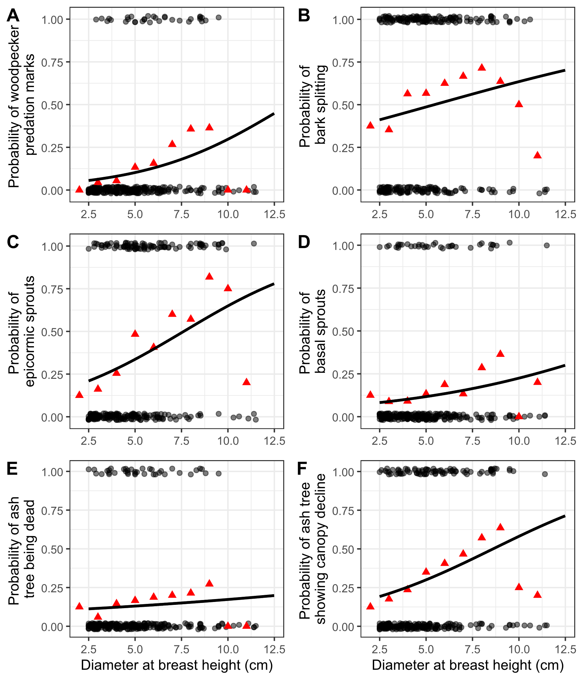
Figure 2. The presence or absence of symptoms of EAB plotted against tree diameter at breast height (DBH) for 272 trees in 9 forest plots. Grey circles are individual trees, which are plotted as y=1 for presence or y=0 for absence (points were jittered slightly up and down). Black line shows the overall fitted model, disregarding each specific random intercept for each plot. Red triangles show the proportion of trees within a DBH bin that have the symptom. For E, tree death is defined as a canopy condition of 5. For F, canopy decline is defined as a canopy condition between 2-5 (minor to complete defoliation).

Relationship between ash species, tree diameter, and canopy condition

The relationship between ash species, DBH, and canopy condition was investigated. Because the majority (280 out of 322) of ash trees (≥ 2.5 cm DBH) were found within hydric plots, we decided to subset the data to hydric plots for investigation of differences between ash species. After removing ash trees which were unidentified (17 trees) or with missing canopy condition (1 tree), we obtained a sample size of 157 black ash (Fraxinus nigra) trees and 105 trees which were either green ash (Fraxinus pennsylvanica) or pumpkin ash (Fraxinus profunda).

A higher proportion of the black ash trees were declining or dead, compared to the green and pumpkin ash, in the plots we surveyed (Figure 3). In contrast, in the 7.5-10 cm DBH range, there were nevertheless still more healthy (canopy condition = 1) black ash than green and pumpkin ash.

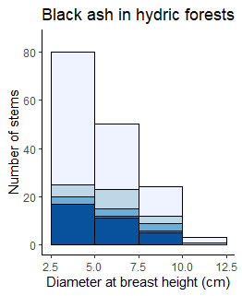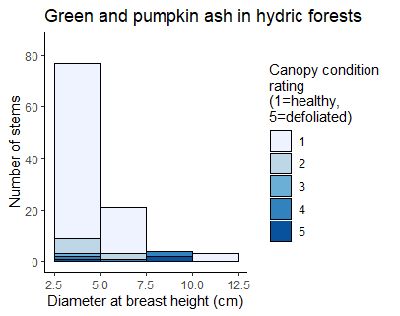
B
A
Figure 3. Histogram of ash tree diameter for different ash species found in hydric forests, shaded by canopy condition rating. The x-axes show diameter at breast height and the y-axes show aggregated counts of all trees found within plots. Bars are shaded according to the number of trees with each canopy condition rating, with darker shades indicating more canopy decline. Trees above 10 cm DBH were counted in 18 m radius main plots, while trees below 10 cm DBH were counted in 8 m radius subplots. A) Black ash (Fraxinus nigra) B) Green ash (Fraxinus pennsylvanica) and possibly pumpkin ash (Fraxinus profunda), which were not separated during species identifications.

Supplementary figures

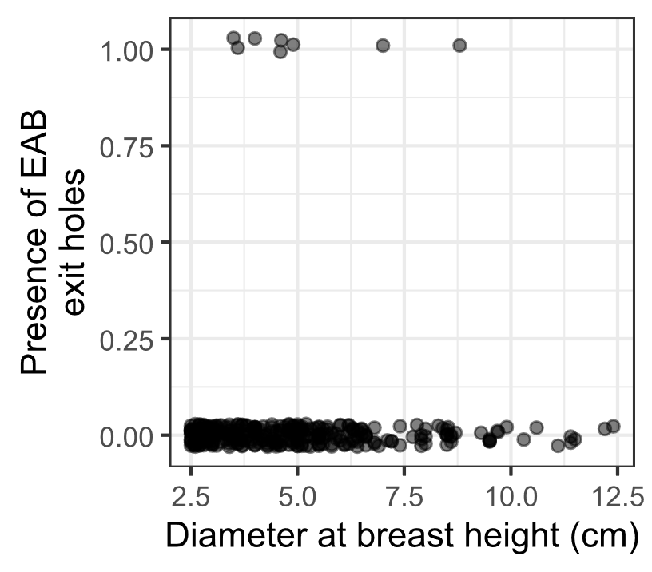
Figure S1. The presence or absence of visible EAB exit holes on the trunk at around eye level. Only 8 of 321 ash trees had EAB exit holes that were spotted.

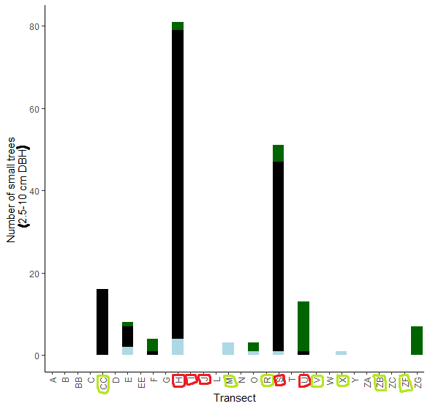
Figure S2. The total number of small ash trees (2.5 – 10 cm DBH) found in 30 completed transects in the Upper Huron River Watershed. Small ash of all canopy conditions are counted. Hydric transects are circled in red, while mesic transects are circled in light green. Bars are shaded based on the proportion of each ash species that was found in a transect. Dark green represents green, white, and/or pumpkin ash; black represents black ash; light blue represents unknown species.

References:

Klooster, Wendy, Kamal Gandhi, Lawrence Long, Kayla Perry, Kevin Rice, and Daniel Herms. 2018. “Ecological Impacts of Emerald Ash Borer in Forests at the Epicenter of the Invasion in North America.” Forests 9 (5): 250. https://doi.org/10.3390/f9050250.
Klooster, Wendy S., Daniel A. Herms, Kathleen S. Knight, Catherine P. Herms, Deborah G. McCullough, Annemarie Smith, Kamal J. K. Gandhi, and John Cardina. 2014. “Ash (Fraxinus Spp.) Mortality, Regeneration, and Seed Bank Dynamics in Mixed Hardwood Forests Following Invasion by Emerald Ash Borer (Agrilus Planipennis).” Biological Invasions 16 (4): 859–73. https://doi.org/10.1007/s10530-013-0543-7.
Knight, Kathleen S., Britton P. Flash, Rachel H. Kappler, Joel A. Throckmorton, Bernadette Grafton, and Charles E. Flower. 2014. “Monitoring Ash (Fraxinus Spp.) Decline and Emerald Ash Borer (Agrilus Planipennis) Symptoms in Infested Areas.” General Technical Report NRS-139. U.S. Department of Agriculture, Forest Service, Northern Research Station. https://www.fs.usda.gov/research/treesearch/46655.
Kost, Michael A., and Ryan P. O’Connor. 2003. “Natural Features Inventory and Management Recommendations for Kensington and Oakwoods Metroparks.” Michigan Natural Features Inventory. Huron-Clinton Metropolitan Authority.
Smith, Annemarie. 2006. “Effects of Community Structure on Forest Susceptibility and Response to the Emerald Ash Borer Invasion of the Huron River Watershed in Southeast Michigan.” Master’s Thesis, The Ohio State University. http://rave.ohiolink.edu/etdc/view?acc_num=osu1394801603.
Ward, Samuel F., Andrew M. Liebhold, Randall S. Morin, and Songlin Fei. 2021. “Population Dynamics of Ash across the Eastern USA Following Invasion by Emerald Ash Borer.” Forest Ecology and Management 479 (January):1–8. https://doi.org/10.1016/j.foreco.2020.118574.

